**TEN GOOD REASONS TO INVEST IN BURKINA FASO**

* A political and institutional stability based on an ongoing quest for social dialogue and political consensus.
* A stable and sustainable healthy macroeconomic context.
* A firm choice for a free-market economy opened to foreign investments.
* A favourable, innovative and especially attractive legal and regulatory framework, with a firm policy relating to the protection, the security and the promotion of investments.
* An area of monetary stability, with a common currency within UEMOA, freely convertible with a fixed parity in relation to the Euro.
* A young, dynamic, enterprising population, as well as an abundant and hard-working workforce.
* A central geographical location in the heart of West Africa, ECOWAS and UEMOA states. A common border with six States of ECOWAS and five States of UEMOA. Such a position enables the country to have access to a potential market of 73 million inhabitants from UEMOA States and over 280 million inhabitants in ECOWAS States.
* A key legal and judicial environment, a harmonised business law that is continuously improved within the framework of the Organisation for the Harmonization of Business Law in Africa (OHADA).
* A good international road network, with a performing international transit system which enables Burkina Faso to be a hub for UEMOA and ECOWAS states.
* Significant economic potential which is not yet sufficiently used in the areas of agriculture, mining, industries, tourism and services.

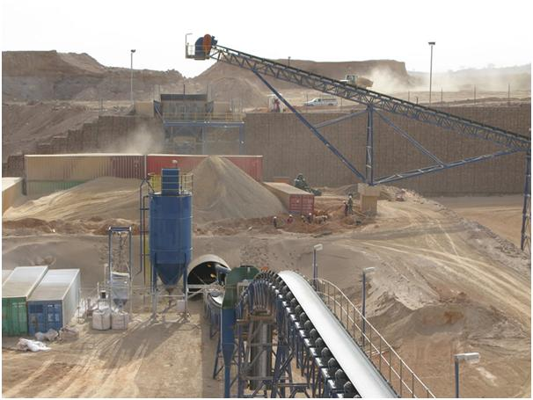



**INVESTMENT OPPORTUNITIES**

**in**

**Burkina Faso**

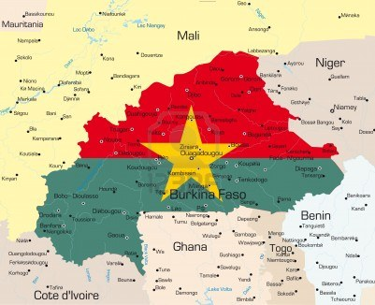

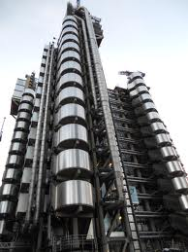

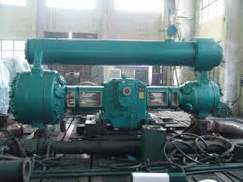

Burkina Faso is the 4thlargest populated market in the Economic community of West African states (ECOWAS).

The market size of Burkina Faso in the high income segment (US$20,000-45,000 annual household income) is 1 million households. It is growing at a rapid pace with high evolution. . Further, Burkina Faso has the highest urbanization rate in ECOWAS, making it an extremely attractive consumer market for retail investments.

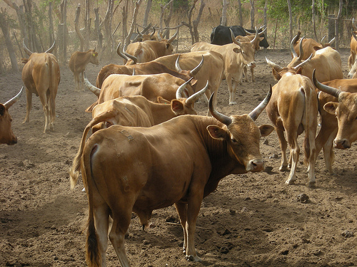

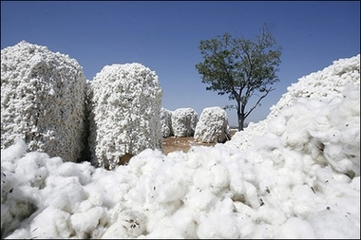

Burkina Faso provides further access to 287 million consumers as an ECOWAS member, with a combined GDP of US$530 billion as of March 2010.

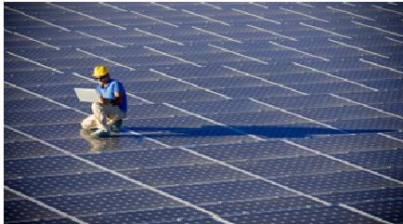

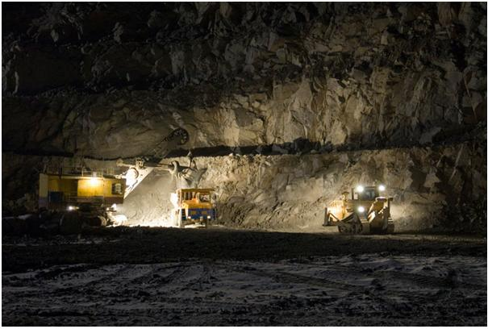

Burkina Faso’s GDP growth rate is the 3rd highest in ECOWAS at 5.8%. Its GDP per capita is the eighth largest in ECOWAS at US$506 in 2010.

Burkina Faso stands as the prime choice for investors, looking to invest in the mining sector in Western Africa.



